#include<stdio.h>

#include<conio.h>

#include<graphics.h>

void main()

{

int gd=DETECT,gm;

initgraph(&gd,&gm,"C:\\TC\\BGI");

circle(300,250,120);

circle(250,210,20);

circle(350,210,20);

line(270,290,330,290);

line(270,290,300,240);

line(300,240,330,290);

rectangle(250,310,350,345);

getch();

closegraph();

}

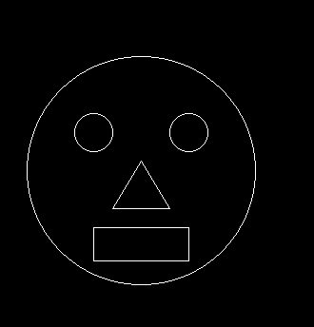

#include<stdio.h>

#include<conio.h>

#include<graphics.h>

void main()

{

int gd,gm;

detectgraph(&gd,&gm);

initgraph(&gd,&gm,"C:\\Turboc3\\BGI");

rectangle(100,200,400,400);

line(200,200,200,400);

line(100,200,150,100);

line(150,100,200,200);

line(150,100,350,100);

line(350,100,400,200);

getch();

closegraph();

}

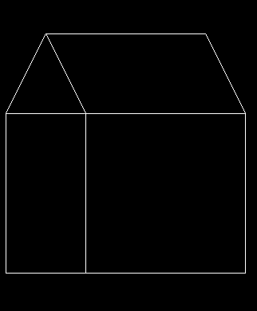

#include<stdio.h>

#include<conio.h>

#include<graphics.h>

#include<dos.h>

void main()

{

int gdriver = DETECT,gmode;

int x,y,i;

initgraph(&gdriver,&gmode,"C:\\TC\\BGI");

x=getmaxx()/2;

y=getmaxy()/2;

for(i=30;i<200;i++)

{

delay(100);

setcolor(i/10);

arc(x,y,0,180,i-10);

}

getch();

}

